Inside Me



Inside me

There are trees

Swaying placidly

Inside me

There is fog

Clouding up the brilliant sky

Inside me

There are blazing streaks of lightning

Flashing across the sky

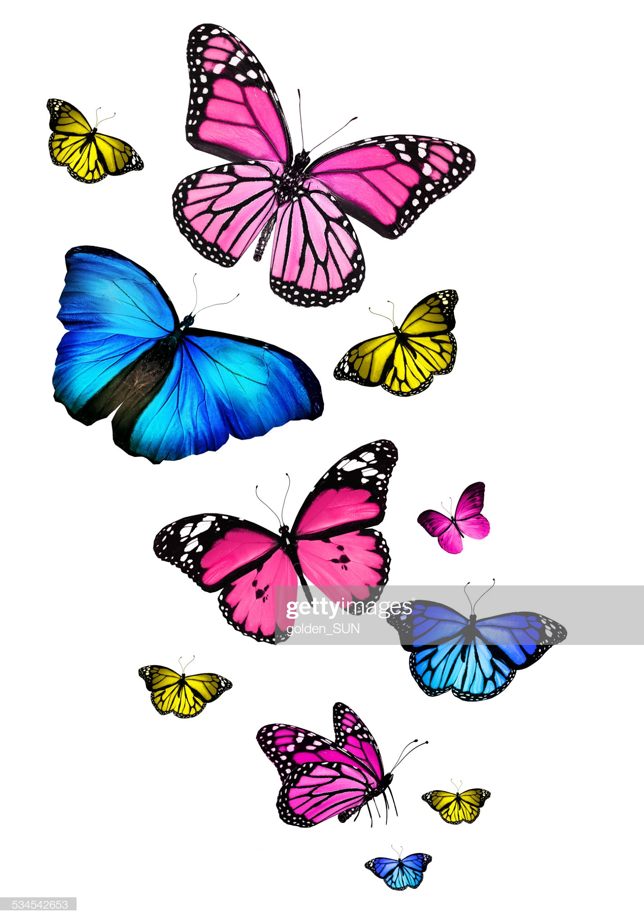

Inside me

There are butterflies

Flapping about in terror

Inside me

There are flies

Caught in the sly spider’s web

Inside me

There are exotic birds

Singing their happy tunes. By Cindy Wu